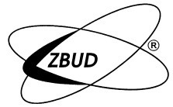Travelling chain hoist type WL-PNS
Marine Execution

- Certified by UDT
- The chain manufactured out of the alloyed heat treated steel with the highest strength parameters acc to DIN 5684– class 8
- uniwersal; adjustable to different travelling beams
- minimum distance A from the hook to the travelling beam
- Anti-Storm protection of the trolley
- Selfbrake mechanism
- 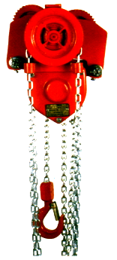

TECHNICAL DATA
Type |  | WŁ-05PN  S | WŁ-10PN  S | WŁ-15PN  S | WŁ-25PN  S | WŁ-32PN  S | WŁ-50PN  S
Load-- | [t] | 0,5 | 1,0 | 1,5 | 2,0 | 3,2 | 5,0
Lifting height | [m] | 3 m for standard execution; max. 30
Number of tension chains |  | 1 | 1 | 2 | 2 | 2 | 2
Lifting strength | [daN] | 28 | 31 | 21 | 32 | 42 | 46
Weight for Hp=3m | [kg] | 22,0 | 37,0 | 40,5 | 68,0 | 69,0 | 112,0
R of track - min | [m] | 1,0 | 0,95 | 1,3 | 1,5 | 1,6 | 2,0
Track beam range | [mm] | 50-90 | 60-106 | 66-106 | 98-143 | 110-170 | 106-170

Dimensions
A | 275 | 275 | 285 | 290 | 422 | 460
B | 246 | 285 | 285 | 360 | 365 | 450
C | 135 | 164 | 164 | 212 | 217 | 274
D | 28 | 28 | 28 | 28 | 32 | 39
E | 98 | 118 | 118 | 126 | 130 | 160
F | 45 | 42 | 42 | 42 | 34 | 40
G | 156 | 162 | 162 | 176 | 180 | 197
H | 158 | 204 | 204 | 255 | 282 | 326
I | 70 | 80 | 80 | 96 | 106 | 120

